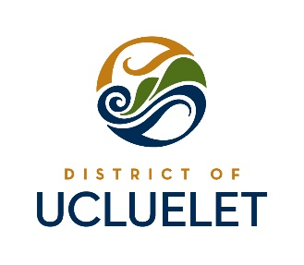
WEST COAST SINGLE-USE PLASTIC REGULATIONS
Key Messages and Social Media Posts for Businesses
Businesses can choose one or more of these messages for use on receipts, check-in confirmations, menus etc. Ideas for social media posts have also been included below.
Key Messages
- Bring Your Own Bag! Help us reduce plastic waste in our community and oceans.
- Straws Suck! Plastic straws can end up in our rivers and oceans. Ucluelet is going plastic straw free!
- West Coast Essentials: Remember your reusable bag, coffee mug and water bottle!
- Reusable bags help keep single-use plastics out of landfills, the marine environment, and other sensitive ecosystems.
- Ucluelet is Plastic Bag Free: We’re making one important, small step to reduce the negative impacts of single-use plastics. Go plastic bag and straw free.
- Plastic straws are not recyclable and contribute to single-use plastics in our oceans and waterways.
- Most plastic pollution at sea starts out on land as litter on beaches, streets & sidewalks.
- Paper bags are available for [minimum] 25 cents. Reusable bags are [minimum] $2.
- Learn more at www.ucluelet.ca/plastics
Social Media Posts
Hashtags: #BYOBag #Ucluelet #StrawsSUCK
- DYK (Did You Know): In 2016, a report by the World Economic Forum suggested that by 2050, the world’s oceans would contain more plastic by weight than fish.
- DYK (Did You Know): Each year, at least 8 million tonnes of plastics leak into the ocean – which is equivalent to dumping the contents of one garbage truck into the ocean every minute.
- [Business name] cares about keeping plastics out of the marine environment. Remember to bring your reusable bag when visiting us! #BYOBag #Ucluelet
- As of [today/DATE] [Business Name] will no longer offer straws unless requested.
- By [Date], [Business Name] will phase plastic straws out in favour of paper straws. #StrawsSUCK
- Coming to #Ucluelet and #Tofino? Remember to bring your reusable bag, coffee mug and water bottle! #WestCoastEssentials #BYOBag
- [Insert Beverage Picture w/o a Straw] Plastic straws are not recyclable and contribute to single-use plastics in our oceans and waterways. Going forward [Business name] will ask if you need a straw and provide paper only. #StrawsSUCK #Ucluelet
- Live like a local in #Ucluelet: #BYOBag and skip the straw!
- Most plastic pollution at sea starts out on land as litter on beaches, streets & sidewalks. #BYOBag #Ucluelet
- #Ucluelet is cutting back the use of plastic by not giving out straws automatically with drinks. Why? Because #StrawsSUCK Learn More: www.ucluelet.ca/plastics

